Andorra****
Haus Andorra is located in the tranquil area of Winkelmatten. The historic chapel, a small grocery shop, the local bus stop and restaurants are all on your doorstep. It is a short walk to the Matterhorn departure station and just a 15 minute walk to the town centre.
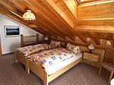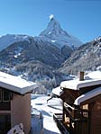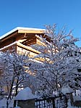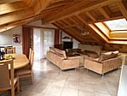

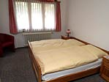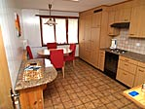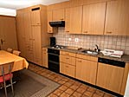

Description:
Haus Andorra has several apartments and studios. It has a sauna available to all residents. The penthouse apartment (sleeps 6) and has a large south facing balcony with beautiful Matterhorn views. It consists of 3 double bedrooms, 2 bathrooms (bath/WC, shower/WC), open-plan kitchen/dining area and large lounge with wood-burning fire place.
The 1 bedroom apartments (sleep 4) and consist of 1 double bedroom and 2 pull down beds in the lounge, 1 bathroom, open-plan kitchen/dining area and lounge. Stunning views of the Matterhorn from the balconies.
The Studio apartments each have 2 pull down beds in the lounge, 1 bathroom (shower WC), open-plan kitchen/dining area and lounge. Exceptional Matterhorn views from the balconies.
All of the apartments have broadband Internet, WIFI connection, flat screen TV with cable television, DVD & CD.

Winter: Seasons & Dates 2007 - 2008
Dates | Season
25.11.2007 ~ 16.12.2007 | Low
16.12.2007 ~ 23.12.2007 | Mid
23.12.2007 ~ 06.01.2007 | Premium
06.01.2008 ~ 27.01.2008 | Mid
27.01.2008 ~ 10.02.2008 | High
10.02.2008 ~ 17.02.2008 | Premium
17.02.2008 ~ 16.03.2008 | High
16.03.2008 ~ 23.03.2008 | Premium
23.03.2008 ~ 06.04.2008 | High
06.04.2008 ~ 27.04.2008 | Mid

Winter: Prices 2007 - 2008
(all prices listed in Swiss Francs)
 | Low Season |  | Mid Season |  | High Season |  | Premium
 | Daily | Weekly | Daily | Weekly | Daily | Weekly | Weeks
Studio | 104.00 | 728.00 | 130.00 | 910.00 | 145.00 | 1'015.00 | 1'120.00
One bedroom (4pers) | 180.00 | 1'260.00 | 245.00 | 1'715.00 | 275.00 | 1'925.00 | 2'135.00
Two bedroom (6pers) | 300.00 | 2'100.00 | 415.00 | 2'905.00 | 455.00 | 3'185.00 | 3'500.00

Please contact us about a reservation request for apartment Andorra — we're happy to answer any questions you might have.

